Robust Photosynthesis in Dynamic Environments

Picture: <http://imgur.com/qKmwS> (old one, originally pulled from a Reddit forum, I could have sworn it was CC, but I can’t find that attribution anymore)

This one is CC: <http://maxpixel.freegreatpicture.com/Seasons-Of-The-Year-Summer-Winter-Autumn-Spring-1127760>

Or something like it…

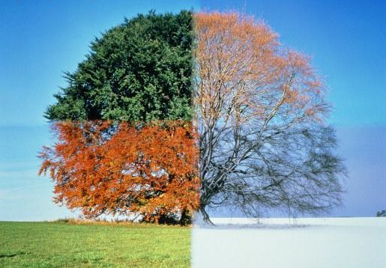

Caption/Summary: *Plants require consistency in photosynthesis, but natural environments are unpredictable in many ways. How do plants adapt the core functions of photosynthesis to “hedge their bets” against ever changing conditions?*

**Main text:**

Plants rely on absorption of light energy to meet their biochemical needs for cell maintenance, growth, and defense. Decades of research have given us a detailed understanding of the core cell machinery required for light capture (e.g. photosystems). These components have been studied the most thoroughly under highly controlled laboratory conditions. In contrast, natural environments are highly unpredictable: light conditions can change in fractions of a second, while rapid changes in other environmental factors (e.g. temperature, moisture) also alter how effectively the photosynthetic machinery can operate. This is particularly a concern for the organism because an imbalance between the light absorbed and utilization of this energy can lead to the formation of destructive by-products (e.g. Reactive Oxygen Species: ROS) and photodamage.

A Grand Challenge of plant biology is to better understand how photosynthetic reactions are regulated and tuned in the context of natural environmental conditions. Plants evolved in an ever-changing environment and the photosynthetic machinery is accordingly compensated in order to anticipate the unexpected. Furthermore, the compensatory mechanisms by which photosynthetic activity is adjusted must act to adjust the system to respond to changes both in the short term (e.g. fluctuating light from a passing cloud) and over sustained events (e.g. heat wave). Despite the importance of these “ancillary” functions to growth and stability of plants in real-world conditions, the nature of these components and how they interact with the core photosynthetic machinery is relatively unexplored. Understanding these processes is critical not only for fundamental understanding, but also to allow for the engineering of crop plants that will have higher photosynthetic efficiencies.

C:\Users\ducatdan.CNS\Dropbox\MSU\Committee\Website development committee\Text for research projects\Project A Ramping severity.tifPart of the difficulty in studying the “ancillary” components of photosynthesis that help to buffer the system against a dynamic environment is the lack of good tools to approach the problem systematically. An ideal platform would possess the following features: 1) capacity to grow plants in dynamic, yet reproducible conditions; 2) real-time monitoring of photosynthetic parameters long time periods; 3) capacity to process a large number of plant strains and mutants, and finally; 4) ability to rapidly analyze and interpret the large datasets that result from such experiments.

Caption/Summary: *Laboratory conditions do not capture the dynamic changes in environmental conditions that exist in nature, yet, scientific practice requires some minimization of the variables in order to rigorously test a specific phenomenon. A challenge to the study of photosynthesis is how can we bring “field-like” conditions to the lab in a controlled manner? Technology developed within the PRL seeks to mimic natural environmental fluctuations in a controlled manner that is reproducible and can be studied with high throughput.*

The PRL is studying the question of how photosynthesis operates in complex environments by using a combination of efforts. We tap researchers across MSU whom have expertise in established methods of studying photosynthesis, develop novel instrumentation (e.g. Dynamic Environmental Phenotyping Imagers, or DEPI), take advantage of large on-campus collections of plants with distinct ecotypes and mutants, and have developed automated data processing streams and bioinformatic pipelines.

Ultimately, this enables our team to “bring the field to the lab.” For example, the growth chambers we’ve developed allow a researcher to program in fluctuating, yet reproducible conditions. It is possible to gather actual environmental data from a natural site (e.g. collect light and temperature readings from an Autumn day in a Michigan park) and then to replay these conditions faithfully within the chamber. On-board detectors monitor the growth and health of the plant lines and can determine how efficiently their photosynthesis proceeds without destroying the plants by using spectroscopic and fluorescence sensors. Furthermore, crowdsourced analysis of plant performance allows for the gathering of data all across the globe and a plethora of real-world conditions. In this way, the PRL is uncovering the functions of heretofore unknown genes that are essential to buffer photosynthesis against environmental fluctuations and stresses.

GIF here? I am envisioning one of the heatmaps that Dave does in closeup to one or two plants. I could make a series of small cartoons that indicate that the light conditions are being changed over time. Perhaps if we can get an image of three plants in a row, one that looks “not like the others” we could show an image of them grown in “normal light”, then switch to a picture of the same three plants in “dynamic” light with the middle plant suddenly standing out in a different pseudocolor.